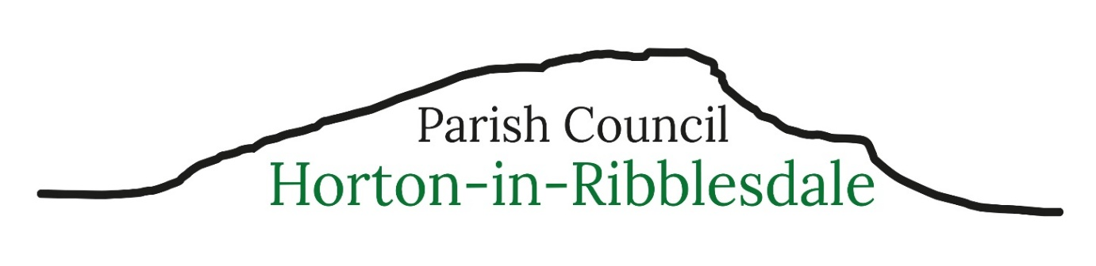

Horton in Ribblesdale Parish Council
Parish Clerk – Michelle Park (at completion of meeting)
clerk@hortoninribblesdale-pc.gov.uk - 07469584759
Minutes of a meeting of Horton in Ribblesdale Parish Council held in the Sports Pavillion on Monday 8th June 2026 at 7.30pm.
Present- Parish Cllrs Martin Hanson (Chair), Fiona Durham (Vice Chair), Lorraine Leary, Ian Mounsey, Thomas Millman and North Yorkshire Councillor David Staveley.
052/27: Apologies for Absence: Parish Cllrs Liz Hornby and Kath Jackson 053/27: Code of Conduct- Localism Act 2011: No items were reported. 054/27: Minutes of the Parish Council Meeting held on 11th May 2026.The Council resolved to recommend approval of the minutes. 055/ 27: Matters Arising (Actions): The former clerk commented that the email and web services from the existing supplier were still unsatisfactory and he recommended that the new clerk looked at services from Parish Online.
056/27: Public Participation:
A member of the public asked that as a result of the closure of a local quarry would lorry traffic increase in Horton? It was not possible to provide this information but other members of the public commented on traffic issues within the parish. It was suggested a member of the North Yorkshire Councils highway team attended a future meeting of the parish council.
Another member of the public asked about the planning application re parking facilities at Holme Farm Campsite. It was confirmed no decision re the application had been made. A member of the public indicated that a member of the Council had written a letter on behalf of the Parish Council objecting to the application. It was agreed North Yorkshire Dales National Park should be approached to confirm the Parish Council were not able to confirm how long the informal car park had been in use.
057/27: A Community Building: The Chair explained he had communicated with the Village Hall Charity as they were not supportive of a public meeting in mid-June and it was agreed informal discussions should continue with the Village Hall Charity and the Playing Fields Charity.
058/27: North Yorkshire Council Reports: NYC Cllr Staveley spoke about road closures and advised the parish council to review the Emergency Plan and it was agreed the Emergency Plan should go on the agenda for the next meeting.
059/27: Financial Statements: The clerk reported that the balances at 5th June 2026 were Savings Account £6509.52, Dinsdale Account £3288.87 and Business Account £15498.86. The clerk gave details invoices to be paid including the final payment as the clerk would finish on 14th June 2026.
Cllr Durham asked about the refund linked to the purchase of defibrillator battery. It was agreed the purchaser of the battery should be refunded as a matter of urgency. The Clerk to seek a refund for the overpayment made to the defibrillator supplier.
The clerk added that invoice for email and web support to the current supplier was outstanding as the council had agreed the invoice should be withheld to reflect the poor service. All requests for a refund had been ignored. The Clerk to contact the supplier to resolve the matter.
060/27: Planning Applications: Listed Building Consent C/44/323/LB UPRN Holme Farm. After discussion the application was noted. 061/27: Green Space: No issues were discussed. 062/27: Highways, Parking and Footway Lighting: No issues were discussed. 063/27: Correspondence: The clerk confirmed all relevant correspondence had been circulated.
Cllr Durham gave details of the Protect the Peaks initiative – this was for a grant consideration. To be discussed at the next meeting.

064/27: Reported incidents to North Yorkshire Police:
14.05.26 – ASB Personal
24.05.26 – Animal concern – dog on Pen Y Ghent
24.05.26 - Road Related offence – motorbikes on Pennine Way
28.05.26 – Firearms Admin
04.06.26 – Concern for walker - CRO

065/27: To determine any matters not included on the agenda which the Chair considers to be a matter of urgency: The Chair thanked the clerk for his 3 and a half years with Horton in Ribblesdale Parish Council

066/37: The Date of the Next Parish Council Meeting
Monday 13th July 2026 at 7.30pm at the Sports Pavillion, Horton in Ribblesdale

