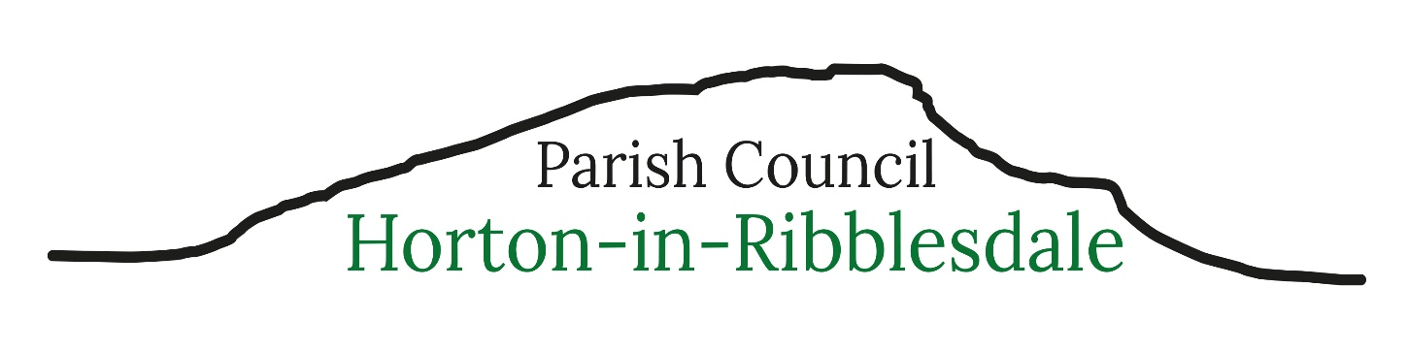
Parish Clerk – Michelle Park
clerk@hortoninribblesdale-pc.gov.uk Telephone 07469 584759
6th October 2026
Dear Parishioner,
You are invited to attend the next meeting of Horton-in-Ribblesdale Parish Council to be held on Monday 12th October 2026 commencing at 7.30pm – at the Quarry Offices, Horton in Ribblesdale.
The public and press are invited to attend the meeting.
125/27: To receive apologies for absence.
126/27: To consider the approval of reasons for absence given by councillors.
127/27: Code of Conduct – Localism Act 2011.
a) To record any councillor’s disclosable pecuniary interests in relation to any item on this agenda. To receive any changes in members’ register of interests & declaration of interests forms and to receive, consider and decide upon any applications for dispensations.
b) To complete new Register of Interest Forms – Cllrs Hanson & Mounsey.
128/27: To confirm the minutes of the Parish Council Meeting held 14th September 26 as a true and accurate record.
129/27: Matters arising (not noted elsewhere on the agenda) – to receive information on the following on-going issues and decide further action where necessary.
- Defibrillator training feedback
- Highways
- Council email addresses
130/27: Public Participation – the period of time allocated for this item shall not exceed 15 minutes.
131/27: Clerk’s Report – To receive an update on actions completed
132/27: To consider and decide upon the following planning applications
- Full planning permission for erection of agricultural building at Foredale Farm, Horton-in-Ribblesdale, Settle, BD24 0EN - C/44/262B
- Listed building consent for division of property to form a holiday let at Higher Studfold
House, Studfold, Horton-in-Ribblesdale, Settle, BD24 0ER – C/44/227E/LB
- Full planning permission for division of property to form a holiday let at Higher Studfold House, Studfold, Horton-in-Ribblesdale, Settle, BD24 0ER – C/44/227D
- Full planning permission for siting of three glamping pods (retrospective) at Cragg Hill
Farm, Horton in Ribblesdale, Settle, BD24 0HW at Cragg Hill Farm, Horton in Ribblesdale,
Settle, BD24 0HW - C/44/189A

133/27: North Yorkshire Council Reports - NYCC Cllr. Staveley 134/27: Financial Matters
- To receive and note the current bank account balances as at 30.9.26
HSBC Current Account £18,946.02
HSBC Savings Account £6,537.65
HSBC Dinsdale Account £3,303.08
- To receive and note the bank reconciliation and the payments made in September 26.
- To note progress with changing the HSBC approvals/users
- Approval of Clerk’s administration expenses
- Approval of spend for Helwith Bridge Car Park Signage
- To receive and note the budget balances as at 30.9.26
- Budget setting for 27/28

135/27: Code of Conduct: To review and adopt the most recent NALC Code of Conduct (item 113/27 from previous meeting)
136/27: Local Plan: To consider developing a plan before the setting of the 27/28 budget detailing the Parish Council’s priorities over the next year(s) (item 114/27 from previous meeting)
137/27: Burial Ground: Verbal update
138/27: Assets: Verbal update
139/27: Green Space: See item 144/27
140/27: Highways, Parking, Footway Lighting &Maintenance:
- Third party & electrical attachments to NYC assets
- Yellow lines - location
- Parking on Parish Council land - update
141/27: Training and Development:
142/27: Correspondence:
- United Utilities proposed works Helwith Bridge area – response to questions raised by the Council
- Additional defibrillators & BHF funding opportunity
- Hedge trimming near Old School Bridge/ bench
- Home to school travel consultation – NYC
- NY CAB & Law Centre annual update and donation request
143/27: Incidents Reported to North Yorkshire Police:
144/27: To resolve to exclude members of the public and press under the Public Bodies (Admissions to Meetings) Act 1960 due to the nature of the business to be transacted at items 100/27 to being prejudicial to the public interest
- Annual landscaping review
145/27: To determine any Matters not included on the agenda which the Chair considers to be a matter of urgency
146/27: The Date of The Next Parish Council Meeting: Monday 9th November 2026 7.30pm at The Pavilion, Horton in Ribblesdale
Michelle Park - Parish Clerk & RFO

