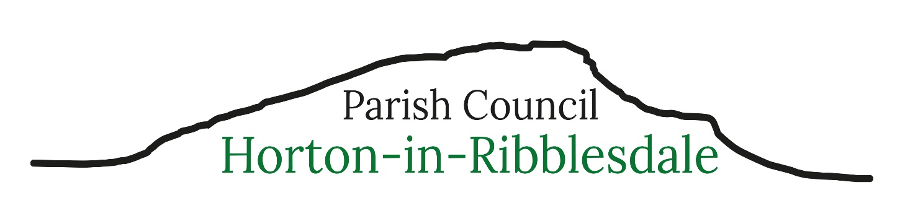
Parish Clerk – Michelle Park
clerk@hortoninribblesdale-pc.gov.uk Telephone 07469 584759
8th September 2026
Dear Parishioner
You are invited to attend the next meeting of Horton-in-Ribblesdale Parish Council to be held in The Pavilion on Monday 14th September 2026 commencing at 7.30pm.
The public and press are invited to attend the meeting.
103/27: To receive apologies for absence.
104/27: To consider the approval of reasons for absence given by councillors.
105/27: Code of Conduct – Localism Act 2011.
a) To record any councillor’s disclosable pecuniary interests in relation to any item on this agenda. To receive any changes in members’ register of interests & declaration of interests forms and to receive, consider and decide upon any applications for dispensations.
b) To complete new Register of Interest Forms.
106/27: To confirm the minutes of the Parish Council Meeting held 10th August 26 as a true and accurate record.
107/27: Matters arising (not noted elsewhere on the agenda) – to receive information on the following on-going issues and decide further action where necessary.
1 – Highways – invited to attend meeting, no confirmation on attendance as at agenda date above
2 - Website and new email addresses

108/27: Public Participation – the period of time allocated for this item shall not exceed 15 minutes.
109/27: Clerk’s Report – To receive an update on actions completed
110/27: To consider and decide upon the following planning applications
C/44/311A - Ribble View Barn, Ashes Farm, Selside, Settle (GR:377839,478225)
Section 73 application to vary Conditions 2, 3, 5, 6, 7, 8 & 12 of C/44/311 (Full planning permission for change of use and conversion of existing storage barn to dwelling and erection of detached garage) in respect of the addition of a front canopy to external door on east elevation, details relating to windows and woodwork, extraction and ventilation, roof-light light mitigation, surfacing, boundary treatment, drainage, external lighting and landscaping (part retrospective)

111/27: North Yorkshire Council Reports - NYCC Cllr. Staveley 112/27: Financial Matters
- To receive and note the current bank account balances as at 31.8.26
HSBC Current Account £10,186.25
HSBC Savings Account £6530.55
HSBC Dinsdale Account £3299.49
- To receive and note the bank reconciliation and the payments made in August 26.
- To note progress with changing the HSBC bank mandate signatories
- Approval of Clerk’s administration expenses
- Approval of NJC Pay Award
- To note the increase in room hire fees at the Pavilion and that fees from 25/26 have been paid
- To approve the purchase of Parish On-line Mapping Software £70 plus VAT per annum

113/27: Code of Conduct: To review and adopt the most recent NALC Code of Conduct
114/27: Local Plan: To consider developing a plan over forthcoming months before the setting of the 27/28 budget detailing the Parish Council’s priorities over the next year(s)
115/27: Burial Ground: To receive an update on capacity and ground maintenance frequency
116/27: Assets: To receive the updated schedule of Parish Council assets
117/27: Green Space: See item 122/27
118/27: Highways, Parking, Footway Lighting &Maintenance:
119/27: Training and Development: Verbal update
120/27: Correspondence:
- NYC Annual Precept Letter
- United Utilities proposed works Helwith Bridge area
- Invite to On-line Parish Forum – 2 max representatives required
121/27: Reported Incidents to North Yorkshire Police:
122/27: To resolve to exclude members of the public and press under the Public Bodies (Admissions to Meetings) Act 1960 due to the nature of the business to be transacted at items 100/27 to being prejudicial to the public interest
- Outstanding quotes for landscaping and tree works
123/27: To determine any Matters not included on the agenda which the Chair considers to be a matter of urgency
124/27: The Date of The Next Parish Council Meeting: Monday 12th October 2026 7.30pm at the Quarry Offices, Cragg Hill Road, Horton in Ribblesdale

Michelle Park
Michelle Park - Parish Clerk & RFO

